Pre-Show Information
The Secretaries
By The Five Lesbian Brothers

This document contains detailed information about the show in order to describe what you should expect when attending.
This includes information about the content warnings, plot, the space, lighting and sound, audience participation, and further access information.
All of the information in this document was correct at the time of publishing. More information will be available closer to the time of performance.
Please note that by discussing the content of the show, the below information will contain key plot points and descriptions of what happens in the performance.
If you would like to avoid these spoilers, please do not read ‘Content Warnings’ and ‘Synopsis’.

If you have any questions, please do not hesitate to contact our Box Office team:
E-mail: boxoffice@youngvic.org
Phone number: 020 7922 2922
The Studio
The Secretaries

This show will take place in our studio, The Clare, which is the smaller sized space of our three performance spaces.
For this performance, there will be seating set out along the North and South walls and a few seats on the east and west side, on the stage floor. The capacity is 60. If you would like to purchase a wheelchair space, then please get in touch via the Box Office.
Access to The Clare is via the Cut Bar. Our ushers will direct you to your seat, so please have your e-ticket ready on your phone or on a physical ticket before you enter the studio, so that they can help you.

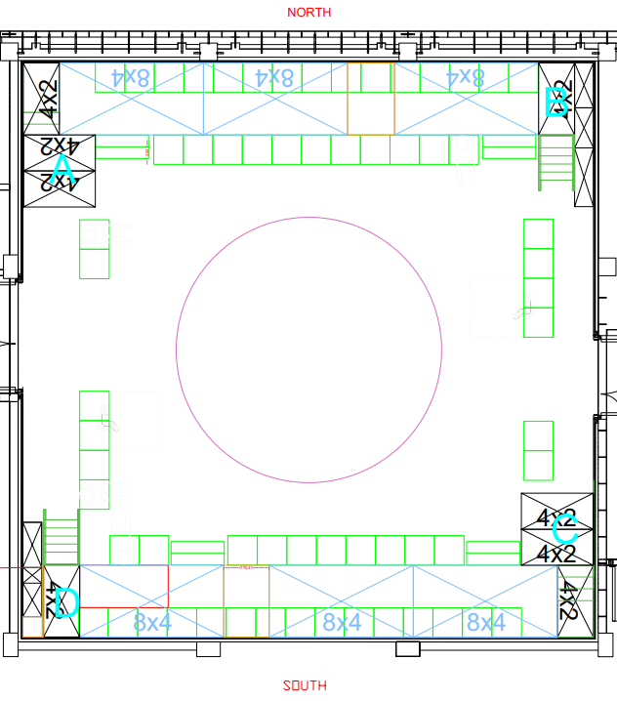

Facilities:
There are toilets located on the ground and first floor at the Young Vic, via The Cut Bar. We have gender-neutral and disabled/baby changing toilets. Sanitary bins are available in all.

Assistance Dogs:
Assistance dogs are always welcome at the Young Vic, if you are planning a visit please let us know in advance which performance you will be attending by calling our box office on 020 7922 2922 or e-mailing boxoffice@youngvic.org and we will be happy to look after your dog during the show.
Content Warnings:
- Sexual harassment and sexual violence
- Self-hatred, self-violence, reference and self-objectification
- Homophobia
- Ableism, body-image sensitivity, fat phobia and diet talk
- Cliques and cult indoctrination
- Menstruation

There will also be guns, drinking alcohol, sexual acts and a lot of stage blood onstage.

If you want to know more about this you can find more specific examples at the end of this document.

There is no audience participation in The Secretaries. The performers are close to the audience, walk through the audience and talk directly to the audience.

Access:
For full information about or access measures, please visit our Access for all page, on our website here: www.youngvic.org/visit-us/access-for-all
- All performances will have integrated audio description. This will be embedded in the performance, meaning that the characters will describe any important visual information in character throughout the play. Pre-Show audio describing the set and costumes in detail will also be made available to audience members.
- All performances will have creative captioning. This will also be embedded into the performance, meaning that the characters' dialogue and descriptions of the sound in the show will be visible for everyone to see.
- All the performances are relaxed. This means you are welcome to move, make noise and respond naturally to the show. You can come and go as you need to. Because of the nature and content of this show, there will be bright lights and loud sounds. We’ll provide more details about sound and light closer to the performance.
- There will be a chill out space available during the performance on the first floor.
- The theatre has step-free access.
- There is a cafe with food and drink and step-free access.

Sensory Information

The Secretaries will:

- Be very loud throughout the show (this will mostly be human voices, but there are also some chainsaws and music).
- Have talking over music and other sounds. The show will be creatively captioned and will also incorporate live and recorded audio description.
- Have bright projections and some glare in audience eyes.
- Have some pulsing lights.
- Have haze. Most of the haze will come from the area on your left as you enter the theatre.
- Have a fake animal drop from the ceiling at one point.
- Have pizza and other food onstage. The theatre is small and you may be able to smell it.

The Secretaries will not:

- Have strobe lights.
- Have the house lights on, note that the theatre is small (60 seats) and it will be easy to see the exits and other audience members.

We’ll provide more detailed information about the sound and lighting closer to the performance date.

Show Synopsis:
Please note that these content notes contain detailed *spoilers* regarding the plot and events within The Secretaries. If you wish to avoid these spoilers but have specific access requests, please speak to a member of the Box Office team. Email us at boxoffice@youngvic.org call us on 020 7922 2922.

The Secretaries is about Susan, Dawn, Ashley and Peaches who are secretaries at a lumber mill. Patty, a newly graduated secretary, joins them early on in the play. As she becomes a part of their group and becomes enamoured with the head secretary, Susan, she discovers that they are a murderous cult that kill a lumberjack every month. (The play follows this monthly cycle.) The secretaries bring Patty into the cult. Eventually Patty has to kill Buzz, the lumberjack she is having sex with/ beginning to date as her final initiation into the cult.

The Secretaries is about the ways that women can themselves inherit and embody sexism and patriarchy. As a result, there’s a lot of physical violence in the show, and specifically a lot of emotional violence relating to body image, sexual trauma, and homophobia. Overall, the play takes a tone which satirizes this violence to express Queer feminist rage.

Because of this complex tone, and the nature of micro aggressions (being that they can be about a tone, a look, a silence, or a subtle gesture), it is difficult to neatly articulate and list absolutely every instance of violence in this show. However, the lists below are to give you a sense of some of the kinds of violence present in the performance.

We want you to feel confident coming to a performance. If you have questions about any of this, please get in touch. You can call the box office on 020 7922 2922 or email boxoffice@youngvic.org who will put you in touch with one of the creative team. Or, you can arrive 60-45 minutes before the performance when either the director, the assistant director or a member of our creative team will be available to answer any questions you have during a brief interval before the show.

Physical violence:

- Peaches, one of the secretaries, begs Patty to hit her every time she eats anything so Patty hits Peaches many times throughout the plot.
- Peaches references another secretary who committed suicide by putting herself on a saw board.
- Susan bites Dawn, another secretary, while performing oral sex on her.
- Patty hits a wombat with a car. She then beats it to death on stage to prevent it suffering more.
- Susan comments on Patty’s underwear and touches her inappropriately without consent.
- Ashley eats printer toner in an attempt to kill herself.
- Patty stabs Susan with a sharp object.
- The secretaries kidnap, torture and kill Buzz off-stage.
- Patty tries to kill herself with an axe on-stage.

Emotional and Structural Violence:

- There’s a lot of discussion of menstruation and all the characters assume that all women menstruate.
- Patty is wildly overqualified for her job.
- The secretaries talk a lot about working out to lose weight consistently throughout the play.
- Lumberjacks catcall and sexually harass Patty.
- Patty tells Dawn, one of the secretaries, that Patty didn’t realize Dawn was a lesbian because she’s pretty.
- Patty is sexist, mentioning that she thinks feminists are humourless and that she didn’t think that she’d like working for a woman.
- There are constant references to dieting, including Slimfast, some characters do not eat solid food and Ashley is bulimic.
- Susan makes Ashley and the other secretaries photocopy their breasts and butts to track their weight loss.
- Ashley calls Peaches a whore and a cunt.
- The secretaries have to sign a celibacy agreement.
- Buzz can’t give Patty an orgasm.
- It is repeatedly suggested that Peaches will be fired because of her weight and appearance.

More information will be available closer to the time of performance.
If you would like any further clarification or have any questions, please do get in touch with our Box Office team.
Email: boxoffice@youngvic.org
Phone number: 020 7922 2922

See you soon!
Welcome Team

