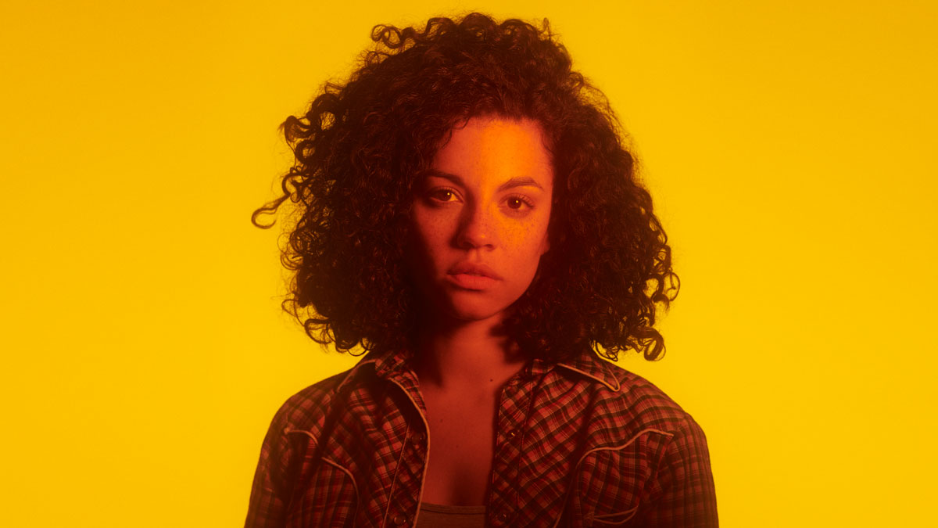
Pre-Show Information
Rodgers and Hammerstein’s Oklahoma!

This document contains detailed information about the show in order to describe what you should expect when attending.
This includes information about the content warnings, plot, the space, lighting and sound, audience participation, and further access information.
All of the information in this document was correct at the time of publishing. More information will be available closer to the time of performance.
Please note that by discussing the content of the show, the below information will contain key plot points and descriptions of what happens in the performance.
If you would like to receive elements of this information but avoid these spoilers, please do not read ‘About the Show’, ‘Content Warnings’ and ‘Lighting, Sound and Stage’.

If you have any questions, please do not hesitate to contact our Box Office team:
E-mail: boxoffice@youngvic.org
Phone number: 020 7922 2922
The Auditorium
Rodgers and Hammerstein’s Oklahoma!

This show will take place in our main auditorium, which is the larger of our three performance spaces.
For this performance, the space will be in a ‘thrust’ arrangement, meaning the seats are arranged on three sides of the stage (see below). The maximum capacity is 389.
Access to the main auditorium is via the doors on the ground floor, inside and outside, depending what door number it says on your ticket. Our ushers are on hand to help you, they wear red t-shirts and jumpers with our logo.
There are different types of seats, depending on what you booked. There are limited stage-side, wooden seats and the rest are our standard, padded bench seats. Our ushers will direct you to your seat, so please have your seat number ready on your phone or on a physical ticket before you enter the auditorium, so that they can help you.

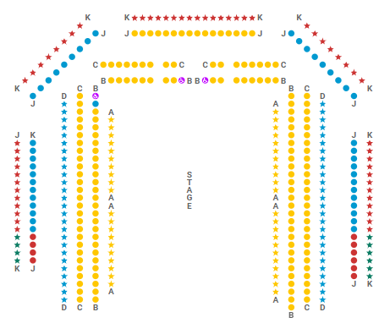
Facilities:
There are toilets located on the ground and first floor at the Young Vic, via The Cut Bar. We have gender-neutral and disabled/baby changing toilets. Sanitary bins are available in all.
Assistance Dogs:
Assistance dogs are always welcome at the Young Vic, if you are planning a visit please let us know in advance which performance you will be attending by calling our box office on 020 7922 2922 or e-mailing boxoffice@youngvic.org and we will be happy to look after your dog during the show.
Access for all:
For full information about or access measures, please visit our Access for all page, on our website here: www.youngvic.org/visit-us/access-for-all
Show Information:
Content Warnings:
Due to the mature content in this production, it is recommended for children ages 12 and up. This production contains haze, smoke, flashing lights, gun imagery, loud gunshot effects, moments of darkness, large amounts of blood, violence, and total blackouts. The show contains disturbing themes including mention of suicide. Children under the age of 4 are not permitted in the theatre.
Food is handled and consumed on stage during the show, audiences can enquire with our Box Office for a full list of allergens before visiting.

Lighting, Sound and Stage:
- Use of smoke (so much that you can't see the person next to you)
- No strobe, but there are flashing video images
- Blood and gore - a character is shot and blood spurts from his chest and a blood cannon soaks two characters quite graphically
- Very loud music
- Gun shots
- Disturbing themes including mention of suicide
- Audience interaction (anyone sitting in the front row may be spoken to or interacted with by actors)
- Lots of guns (there are approx. 100 guns hung on the walls in the theatre)
- Very bright lighting states (most of the show takes place in very bright lighting - like it feels like you want sunglasses when the light first comes up)
- Extreme darkness (with fire exit signs temporarily switched off)
Show Synopsis:
Synopsis:
Act I
(“Oh, What A Beautiful Mornin’”) In the territory of Oklahoma, Curly, a handsome cowboy, comes to Aunt Eller’s porch to ask Laurey to the Box Social. Will Parker stumbles in, having just won a steer-roping contest at the Kansas City Fair. Will leaves to find Ado Annie as Curly returns. He asks Aunt Eller if it’s not him, whose affection does Laurey lean to?

Jud Fry, the hired hand on the farm, appears and reveals he asked Laurey to the Box Social. When Laurey doesn’t deny this, Curly confirms his date with Aunt Eller, revealing the surrey (carriage) he’d described was hired for real after all. Curly leaves, bragging again about his hired ride, while Laurey, stunned, hides her envy.

Laurey begs Aunt Eller not to go with Curly so she doesn’t have to ride alone with Jud. Laurey just didn’t want to give Curly the satisfaction of going with her. Eller brushes aside Laurey’s fears as Ado Annie and the peddler, Ali Hakim, arrive.
Aunt Eller has a bone to pick with the peddler about a past purchase. Laurey tells Ado Annie that Will is looking for her. Ado Annie wasn’t counting on Will being back so soon – the peddler is driving her to the Box Social. Laurey is tickled by Ado’s inability to choose between the two. She hates disappointing a beau when he’s paying a call (“I Cain’t Say No”).
Ado Annie interprets Ali Hakim’s offer to take her to “paradise” – an upstairs room at the hotel in Claremore – as a proposal of marriage, but his intentions are much simpler. Laurey’s concerns about making up her mind prompt Ali to sell her a bottle of Egyptian Smelling Salts said to have the ability to decide a difficult choice. Will unexpectedly arrives, announcing his return. Will tells Ado Annie about his $50 cash prize. Unfortunately, he spent it on gifts for her and no longer has the money to give her father.
Feeling rebuffed by Laurey, Curly takes up with Gertie Cummings, who flirts with him as the women prepare lunch baskets. Laurey declares her independence (“Many A New Day”).
Ado Annie tells Ali Hakim she has promised herself to Will Parker, and Ali is relieved. Ado Annie’s father, Andrew Carnes, enters with a shotgun in hand and learns that Will Parker spent the $50 needed to take Ado’s hand in marriage. He also hears about the “purty” talking Ali’s been giving his daughter and suggests to Ali, opportunistically with his gun, that it indeed does sound like a marriage proposal. Ado Annie leaves, excited to tell the girls about her engagement to the peddler, leaving Ali Hakim to vent his frustration (“It’s A Scandal! It’s A Outrage!”).
Curly is now taking Gertie Cummings to the Box Social, and when she leaves, he mentions to Laurey that everyone’s expecting him to take her instead. Playfully, they wonder how such outlandish rumors begin (“People Will Say We’re In Love”). Curly plainly asks if she wants to tell Jud she’d rather go with him, but Laurey says she can’t. Curly sets off to visit Jud to understand why.
In his smokehouse, Jud polishes his gun as Curly notices photos of naked women on his wall. Curly, noting a rope hanging from the shed’s wall, says, “You could hang yerself on that, Jud,” manipulating Jud into fantasizing about killing himself (“Pore Jud is Daid”). Jud warns Curly to stay away from Laurey, but Curly’s provocation spurs Jud into firing a warning shot. Calmly, Curly shoots a bullet straight through one of the roof’s knotholes just before Aunt Eller interrupts.
Ali tries to sell Jud more naked postcards, but Jud is interested in something else: “The Little Wonder,” a picture-peeping toy with a surprise blade that pops out from a spring, meant to stab the person you’re showing it to. Ali says he doesn’t handle dangerous items like that, and leaves Jud to fester and churn about living in what Curly referred to as “this lousy smokehouse” (“Lonely Room”).
Back on her porch, Laurey takes a whiff of smelling salts as her girlfriends surround her. She drifts off into a dream, and a ballet begins (“Dream Sequence: Out of My Dreams”). In the dream ballet, Laurey prepares for her wedding, but is shocked to see that the man she’s marrying is Jud. Curly enters and tries shooting at Jud who persists toward him, immune to the bullets. Jud then grabs Curly by the throat. Curly collapses and Jud carries Laurey away over his shoulder as she blows a kiss to Curly’s dead body.
Laurey suddenly wakens as Jud shakes her from her revery. It’s time to go to the Box Social. Curly, who had arrived unexpectedly, stands alone, defeated, watching Laurey and Jud leave together.
Act II
At the Box Social, the crowd is dancing, and Carnes begins to sing a song about the necessary bond between cowboys and farmers (“The Farmer and the Cowman”). Aunt Eller is elected auctioneer for the coveted lunch hampers; the men will bid on individual boxed meals prepared by the town’s women.
Will confronts Ali about his apparent engagement to Ado Annie and challenges the legitimacy of his love for her. Will knows his love for Ado is real because of all the gifts he bought her with the $50 he was supposed to use to win her father’s favor. Ali suggests he could buy some of the gifts back, to peddle, if Will was willing to sell them. Ali pays Will generous prices for each gift. Will, ignorant of the “Little Wonder’s” sinister utility, sells it to Jud, eventually making all $50 back.
The auction is now down to the final two hampers: Laurey’s and Ado Annie’s. Ali Hakim wins Ado’s basket after Will almost loses the $50 once more, leaving Will still eligible to marry Ado in the eyes of her father. Laurey’s basket is a popular lunch, but Jud keeps outbidding everyone by a few bits until Aunt Eller can’t wait for another bid any longer. Curly steps in and sells his saddle, horse and gun, outbidding Jud’s entire savings of two years: $42.31. Curly wins and Aunt Eller ends the auction abruptly.
Now that Will and Ado Annie are engaged, Will wants Ado Annie’s to stop having fun with other fellas. With some convincing, she agrees as best she can, and they share a kiss (“All Er Nuthin’“).
Jud and Laurey are still dancing, but she is uncomfortable – he knows she doesn’t like him and regards him as a filthy hired hand. Growing angrier, Jud makes a vague threat and Laurey fires him on the spot. It’s her family’s farm, after all, and she has the right to hire and fire people. Jud storms off. Laurey sits, terrified, looking for Curly, who then appears. She can’t hide her desperation to be safe with him, the one she trusts and desires. Laurey explains her fear of Jud, and Curly promises to make it all right. They flirt, and he begs her to marry him. She says yes, and he elatedly declares his love for her (“People Will Say We’re In Love” Reprise).
Three weeks later, Laurey and Curly are married. The newlyweds and their friends all come out to the back of the house, cheering and celebrating (“Oklahoma”). Suddenly, Jud arrives uninvited and the celebrations stop. Jud claims he is there to give the groom a gift, but first he wants to kiss the bride. As Jud moves in to kiss Laurey, Curly pulls him back and Jud punches him. The fight continues until Jud pulls a gun on Curly and shoots him in the chest. The crowd tries to help, but Jud is dead.
The newlyweds are distraught. There’s nothing that can be done about Jud, but Cord Elam, a Federal Marshal, thinks Curly should turn himself into the judge that night, despite their train leaving town in 20 minutes. Aunt Eller suggests to Andrew, the judge, that they hold an informal court there. Cord Elam disagrees at first, but Andrew decides they can give Curly a fair trial without locking him up on his wedding night. Andrew, as the Judge, guides Curly into a self-defense plea. Cord Elam suggests he doesn’t feel right about this, but Aunt Eller and the wedding attendees, now witnesses for the court, support the Judge’s immediate verdict of not guilty. Everyone hurriedly gets the newly wedded couple into the surrey, waving them off to their honeymoon (Finale Ultimo: “Oklahoma”).

More information will be available closer to the time of performance.
If you would like any further clarification or have any questions, please do get in touch with our Box Office team.
Email: boxoffice@youngvic.org
Phone number: 020 7922 2922

See you soon!
Welcome Team

