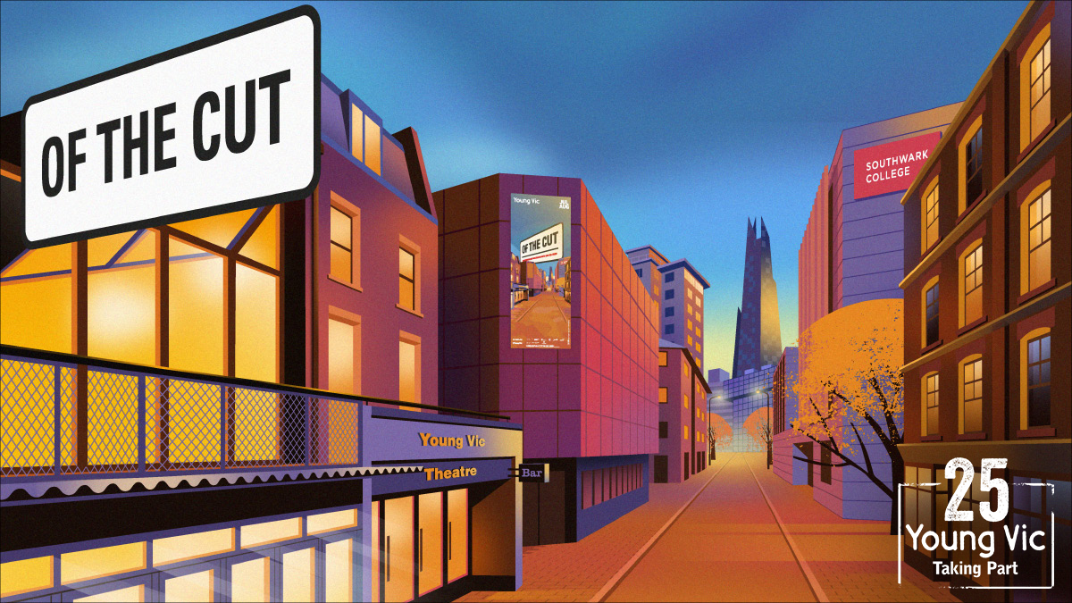
Pre-Show Information
A Taking Part production from Young Vic and TEA films
Of the Cut
Written by Yasmin Joseph and the Company
Directed by Philip J Morris
This document contains detailed information about the show in order to describe what you should expect when attending.
This includes information about the content warnings, plot, the space, lighting and sound, audience participation, and further access information.
All of the information in this document was correct at the time of publishing. More information will be available closer to the time of performance.
Please note that by discussing the content of the show, the below information will contain key plot points and descriptions of what happens in the performance.
If you would like to receive elements of this information but avoid these spoilers, please do not read the sections at the end of this document ‘Show Information’ and ‘Show Synopsis’.
If you have any questions, please do not hesitate to contact our Box Office team:
E-mail: boxoffice@youngvic.org
Phone number: 020 7922 2922
The Maria & Promenade
Of the Cut

This event will start in The Maria (our medium sized studio space) followed by a promenade around the local area, including Southwark College and St Andrews, Waterloo. You will navigate the performance through a route across the cut.
Please arrive 15 minutes before the show starts. You will be given a wristband which will indicate the group you will be with to watch the performances.
Please wear comfortable shoes and clothing as performances will be indoor and outdoor and include standing for up to 7 minutes. If you are unable to stand, please contact the Box Office on 020 7922 2922 or email boxoffice@youngvic.org and we can provide a chair for you.
Of the Cut will be led by a team of multi-disciplinary creatives, fusing film, stage, sound, imagery and story together. After the first section, the audience will be separated into groups where they will experience performances in different orders and locations until coming together for the final section.
All performances are relaxed. You can move, make noise and respond naturally to the performance. Performances are not sensory adapted.
Please arrive at the Young Vic with your ticket ready on your phone or have it printed before you enter or you can collect from box office.
Facilities:
There are toilets located on the ground and first floor at the Young Vic, via The Cut Bar. We have gender-neutral and disabled/baby changing toilets. Sanitary bins are available in all. All indoor venues will also be accessible with lifts & ramps and toilet provided.
Assistance Dogs:
Assistance dogs are always welcome at the Young Vic, if you are planning a visit please let us know in advance which performance you will be attending by calling our box office on 020 7922 2922 or e-mailing boxoffice@youngvic.org and we will be happy to look after your dog during the show.

Access for all:
For full information about or access measures, please visit our Access for all page, on our website here: www.youngvic.org/visit-us/access-for-all
Show Information:
Content Warnings:
- Loud atmospheric noises
- Moments of bright light
- Audience interaction/participation in some scenes
- Film sequences on screens (with captions) as part of the performance
Show Synopsis:
Please note you may experience the scenes in a different order depending on the route you will take for the performance.
Section A: Scene 1
A short film showing snippets of everyday life on The Cut: opening shops, stopping for cups of tea, watching nature, walking into work, unloading the set for a play. The setting is a Victorian market, filled with various vendors, all busy at work. Some of them come into the audience. We hear a soundscape of their many voices, offers and stories.
(Live performance) 3 characters discuss the meaning of community and its stories. They start to tell the story of their community on The Cut, discussing the past, when it was a Victorian market. Then we shift to present day, where 4 builders discuss new building plans for the street and the risk of losing The Cut’s magic.
Section A: Scene 2
A short film of students at the Young Vic on a staged school trip, which flows into the scene with the actors (live performance). The teacher and the students discuss what it means to represent the school. The walls then start to talk to the students (actor’s voices).
Section A: Scene 3
(Live performance) A wealthy couple in a magic shop along The Cut. The Sales Assistant looks overwhelmed and like they’re losing the will. They bicker a bit in front of her, in a typical married couple way. She tries to sell them an elixir, to improve their partnership. They also look at truth serum. Sales Assistant goes on an overdue lunch break, the couple continue to disagree and bicker amongst themselves, until one partner tries something in one of the jars.

Section B: Scene 1
Short film of the ancient Cut, at the Victorian market, extremely hard at work. Characters faces are seen in detail. They appear worn and weathered, forgotten. A shot of their many hands coming together to hold a seed to the sky. It’s a hopeful image.
(Live performance) We then go to a group of historians at a weekly knitting circle. It’s quiet and focused work, but we sense tension in the air. After a long silence, they speak. They discuss their worries and issues within the Lambeth area – Council, money and the purpose of the group.
Section B: Scene 2
(Live performance) Sounds of heavy rain – a female character rushes into the building for shelter, she fights with her broken umbrella until it closes. She unravels the cardigan on her head that she’d used to protect her hair. She catches her breath, takes in her surroundings, realises she’s in a church, would rather not be.
She tries to book a taxi but fails. She leaves a voice note on her phone, explaining that she’s running late. She reapplies make-up and seems restless. She inspects the faces in the stained-glass windows, takes out a mirror, compares and wonders what her own face would look like immortalised in the same way. Tries a few poses. It thunders, louder and she is flustered.
Then an iPhone alarm comes from somewhere in the space. She can’t trace the source; she begins to get freaked out. Then, emerging from what feels like nowhere. Dressed in a Sainsbury’s uniform for work. They talk about the weather for a bit and then about their stories and why the person dressed in the uniform is sleeping in the church (she thinks they might be a ghost).
They share a magical moment of connection in the rain, with light and noise and then part ways, feeling changed.
Section B: Scene 3
(Live performance) A customer, owner and dad in a chip shop. The customer queries some of the fancy names for British dishes on the menu. The owner explains they’re exploring new takes on British classics with their head chef. The customer mocks this and finds it all a bit daft, she opts for just chips.
She sits and eats the chips, alone. As soon as she takes a bite, the world around her is transformed, time is reversed and through the sound and lighting and we see an older version of the chip shop sign. We are now in the past; the customer is now a woman in a girl’s body. Her dad appears and sits on the table with her and encourages her to eat up. A whoosh noise fills the air and the sounds of The Cut return, building with energy and then, white noise.
Section C : Scene 1
Short film of bustling Victorian market. A snapshot of the modern cut, pacy and full of faces. The image of many hands holding a seed to the sky.

The image/sound of that seed falling and growing beneath the ground. Then we cut to a news reporter discussing an accident on a nearby construction site and the nuances with the changing of The Cut for the community.
We then cut to a scene of a protestor lying on the ground, disputing a residence permit. There is also a football game happening nearby. We go back to the reporter who reports about one of the young men.
Section C: Scene 2
We are in a dream. The bones of the estate still exist but somehow the world is changed, distorted. Our characters are all inspecting random objects, looking at their skin and bodies as if they’re brand new. One character casually gallops in on a horse and chats to the other characters, in the dream.
Section D: Scene 1
All the cast assembled in the space. They are all dressed as characters we have seen in previous scenes. They stand and inspect the hole in the ground and each speak.
Ends with a final film which will be captioned. This will include the characters in the play reflecting on their lives on The Cut.

More information will be available closer to the time of performance.
If you would like any further clarification or have any questions, please do get in touch with our Box Office team.
Email: boxoffice@youngvic.org
Phone number: 020 7922 2922

See you soon!
Welcome Team

Part of Taking Part 25, a season of work celebrating 25 years of the Young Vic’s creative engagement department.
Of The Cut is generously supported by IHS Markit.

